**ASSIGNMENT-4**

|  |  |
| --- | --- |
| Date | 30 October 2022 |
| Team ID | PNT2022TMID39661 |
| Name | Mohammed Affan C |
| Student Roll Number | 510619104041 |
| Maximum Marks | 2 Marks |

**Problem Statement:**

Write code and connections in wokwi for ultrasonic sensor. Whenever distance is less than 100 cm send "alert" to IBM cloud and display in device recent events.

CODE :

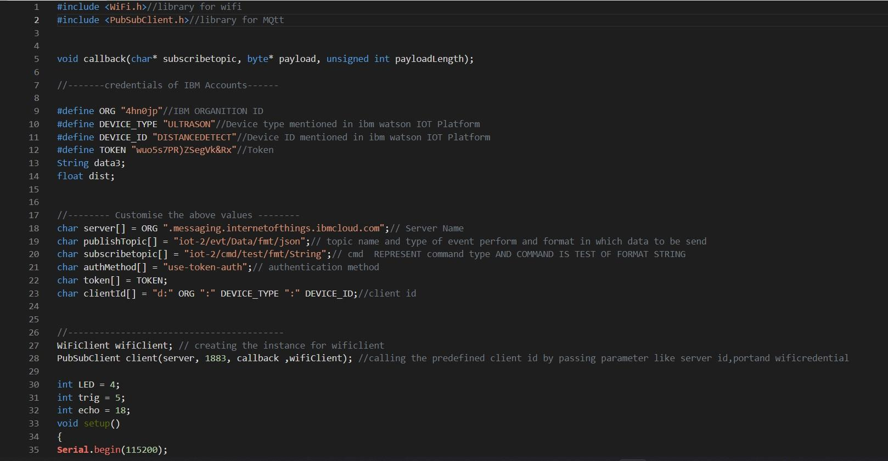

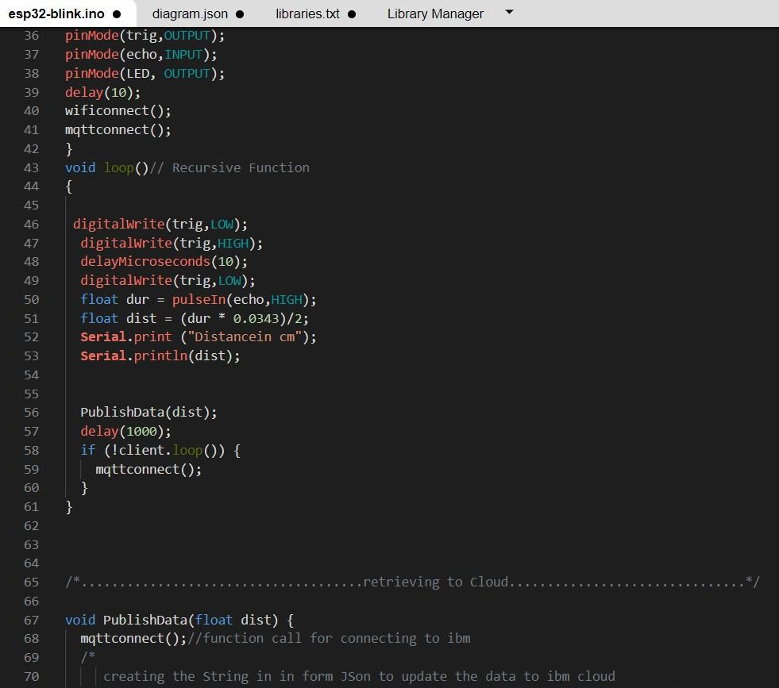

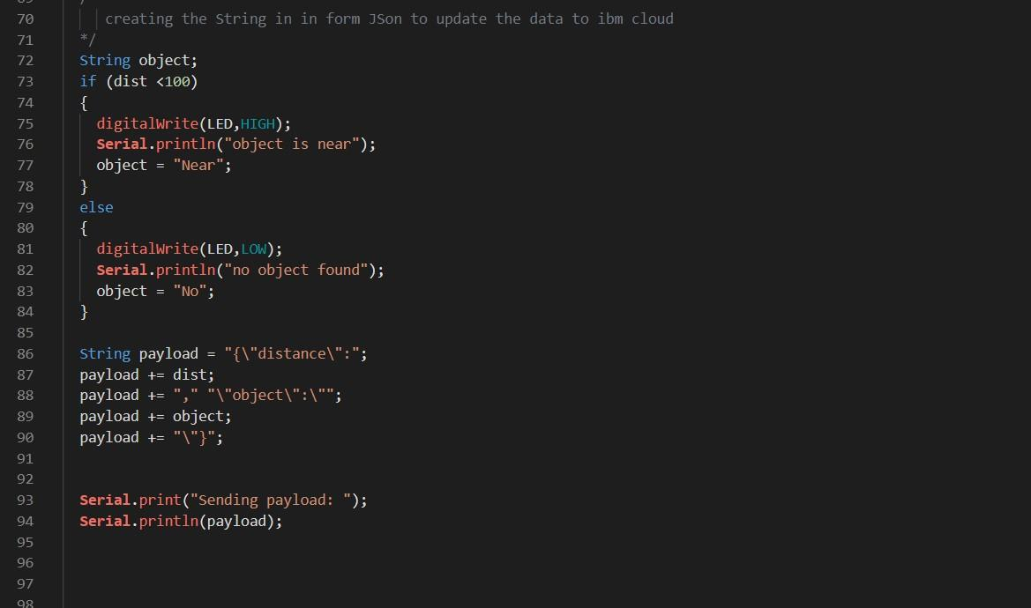

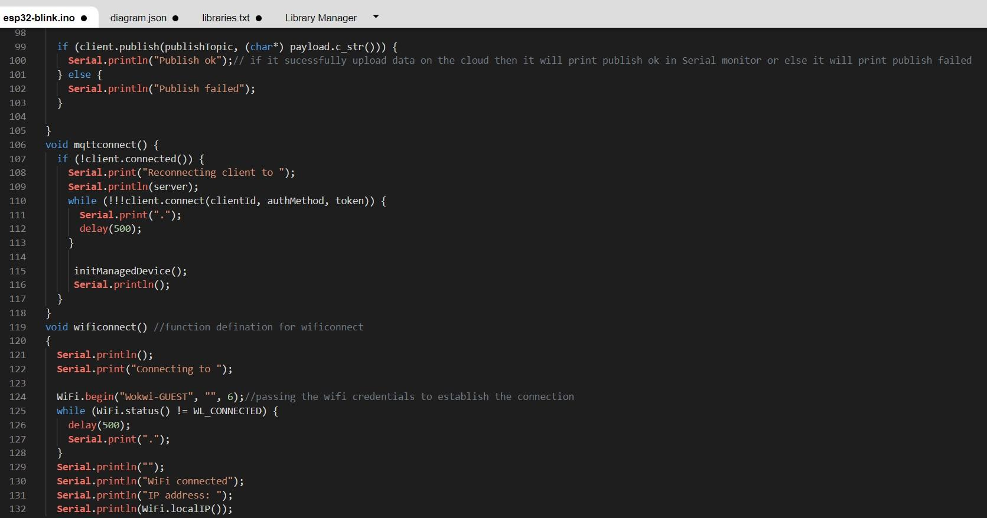

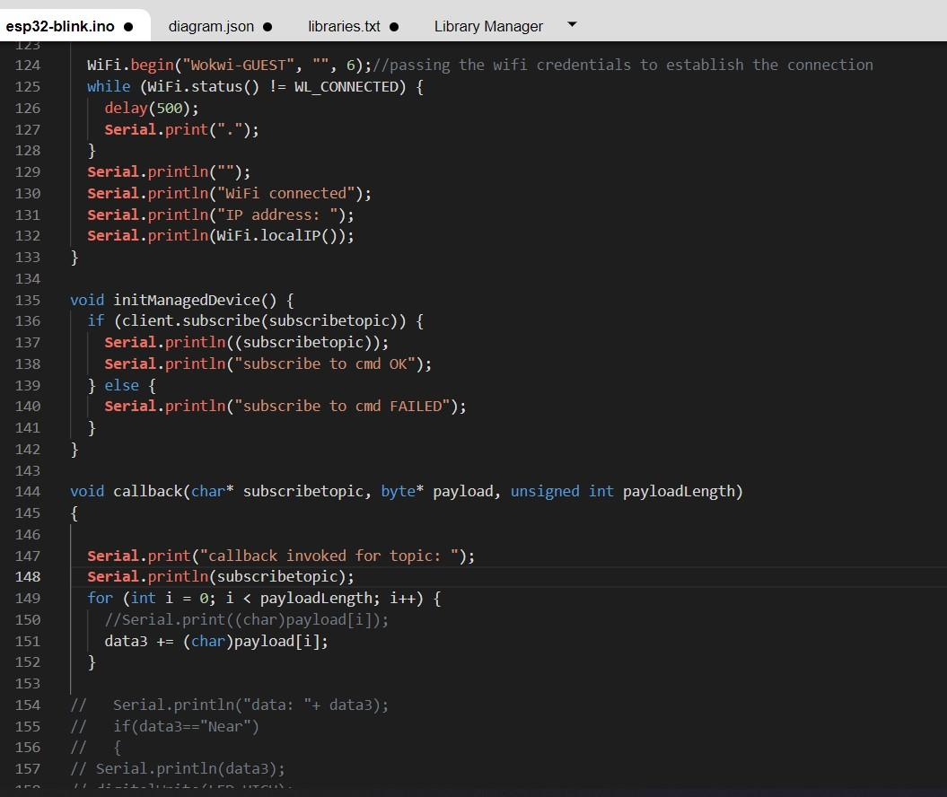

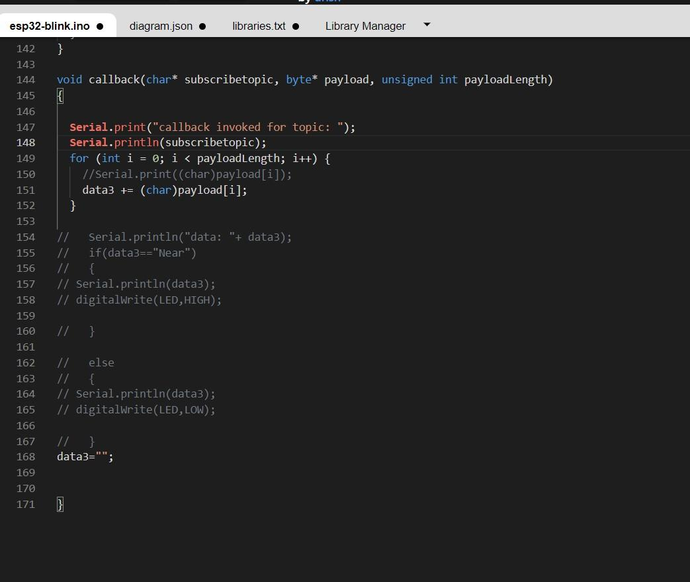

OUTPUT:

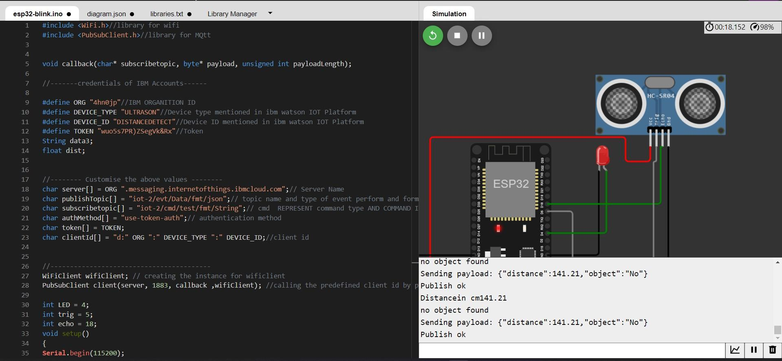

# Data send to the IBM cloud device when the object is far

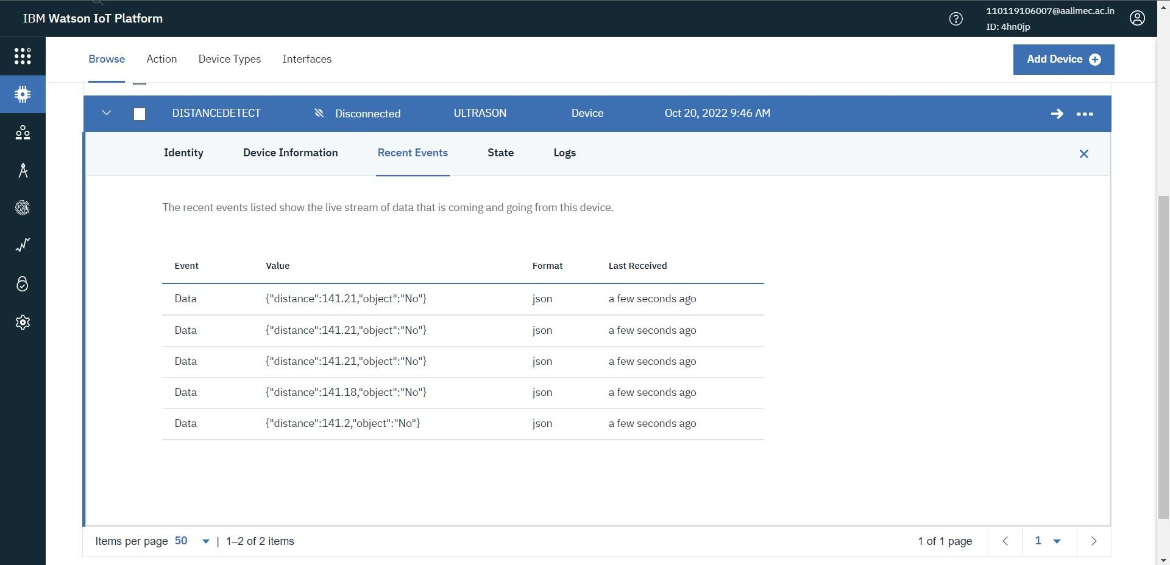

# when object is near to the ultrasonic sensor

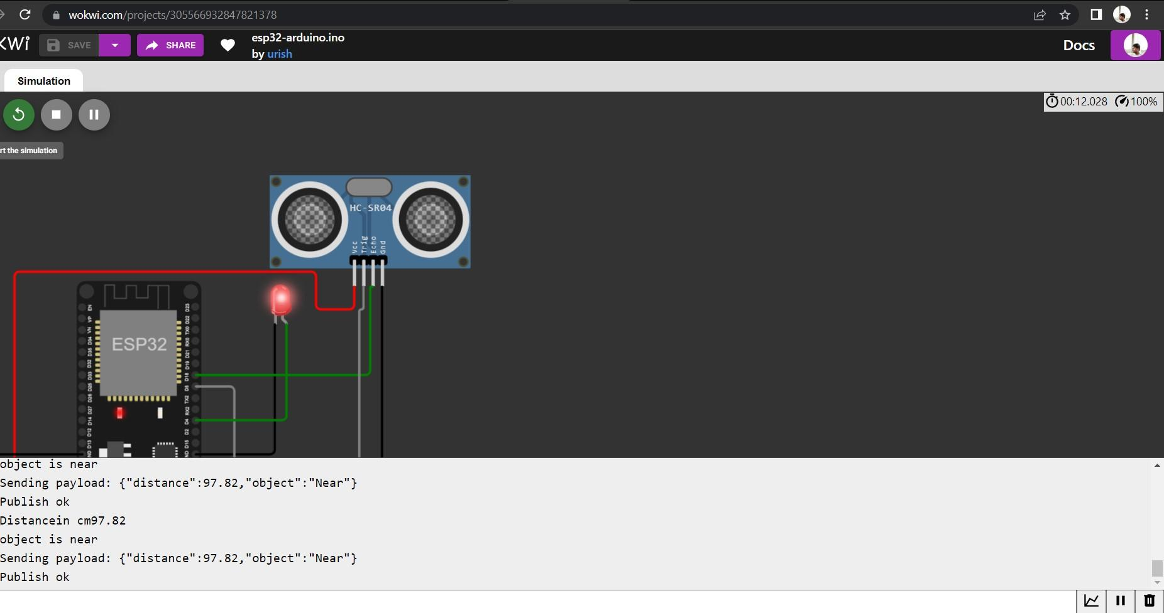

# Data sent to the IBM Cloud Device when the object is near

